Direction for completing the Vocabulary Planning Worksheet

- Go to Google Drive - https://drive.google.com/open?id=19um6NigKC0m05yoo9ga5MiDX8yc7H8SC
- In the folder find 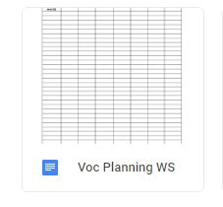
- Right click on the icon select Make A Copy from the drop down menu
- Open the copy
- Enter your information on the form
- In the upper left corner click on the file name. When a blue box appears around the text you can edit. Add your name to the beginning. 

Should you need any assistance, feel free to email me at marrenma@buffalostate.edu

